E-School: World History
Topic:
- World History Quiz – Educational application for world history tests
- Subject: Information Technologies School
- year: 2025/2026
Contents
E-School: World History 1
1. Authors 1
2. Summary 2
2.1 Project Goals 2
2.2 Main Development Stages 2
2.3 Implementation 3
2.4 Application Description (diagram) 4
2.5 Conclusion 4
3. References 5

1. Authors
Full Name | Class | Role
Ангел Пиерре Андре Фриедириш | 9th grade | Scrum Trainer
Никита Сергеевич Кощеев | 9th grade | Backend Developer
Александър Ивайлов Петров | 9th grade | Frontend Developer
Мирослава Ивановна Хмара | 9th grade | Designer

2. Summary

2.1 Project Goals
The goal of the World History Quiz project is to create an easy-to-use educational application that helps students practice their knowledge of world history. The application provides:
- a short lesson
- a 20-question test
- automatic grading
- statistics for all participants
The project addresses the following needs:
- lack of a quick and convenient way to practice
- need for automatic grading
- opportunity for self-study
Existing solutions include online quizzes such as Kahoot and Quizizz, but they require internet access and registration. Our application works offline, is fast, and suitable for school use.

2.2 Main Development Stages
- Planning
  - choosing the topic
  - defining the features
- Creating the structure
  - defining Question and Student
  - building the menu
- Developing the functionalities
  - Lesson Mode
  - Exam Mode
  - Stats Mode
  - input validation
- Testing
- checking the questions
- verifying the grading
- finding and fixing errors

- Documentation
- writing the project description
- creating the diagram
- writing the conclusion

2.3 Implementation
The project is implemented in C++, because:
- the language is fast and suitable for console applications
- it supports structures and vectors
- it compiles easily on all operating systems
Technologies used:
- C++
- Libraries: <iostream>, <vector>, <string>, <ctime>, <algorithm>
- Compiler: g++

2.4 Application Description (diagram)
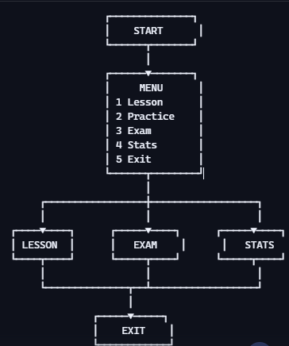

2.5 Conclusion
The project successfully delivers an educational application for history quizzes. The main results are:
- a working menu
- a 20-question test
- automatic grading
- student statistics
The application can be used in class or for self-study.
Future development possibilities:
- adding Practice Mode
- saving results to a file
- graphical interface
- more questions and categories
The project demonstrates that even with basic C++ knowledge, it is possible to create a useful and functional application.

3. References
- Online resources for C++ syntax
- School programming lessons
- Standard C++ library documentation

